Lab - Configure Router-on-a-Stick Inter-VLAN Routing

# Topology

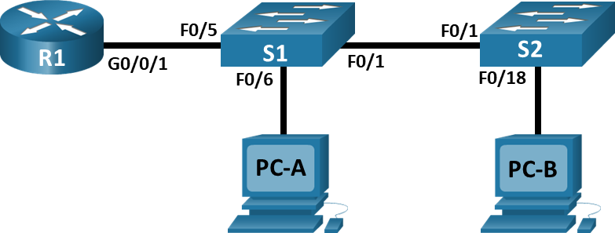

**VLAN 4**

**VLAN 3**

# Addressing Table

|  |  |  |  |  |
| --- | --- | --- | --- | --- |
| Device | Interface | IP Address | Subnet Mask | Default Gateway |
| R1 | G0/0/1.3 | 192.168.3.1 | 255.255.255.0 | N/A |
| R1 | G0/0/1.4 | 192.168.4.1 | 255.255.255.0 | N/A |
| R1 | G0/0/1.7 | 192.168.7.1 | 255.255.255.0 | N/A |
| PC-A | NIC | 192.168.3.3 | 255.255.255.0 | 192.168.3.1 |
| PC-B | NIC | 192.168.4.3 | 255.255.255.0 | 192.168.4.1 |

# VLAN Table

|  |  |  |
| --- | --- | --- |
| VLAN | Name | Interface Assigned |
| 3 | Management | S1: F0/6 |
| 4 | Operations | S2: F0/18 |
| 7 | ParkingLot | S1: F0/2-4, F0/7-24, G0/1-2  S2: F0/2-17, F0/19-24, G0/1-2 |
| 8 | Native | N/A |

# Objectives

Part 1: Build the Network and Configure Basic Device Settings

Part 2: Create VLANs and Assign Switch Ports

Part 3: Configure an 802.1Q Trunk between the Switches

Part 4: Configure Inter-VLAN Routing on the Router

Part 5: Verify Inter-VLAN Routing is working

# Instructions

## Build the Network and Configure Basic Device Settings

In Part 1, you will set up the network topology and configure basic settings on the PC hosts and switches.

### Cable the network as shown in the topology.

Attach the devices as shown in the topology diagram, and cable as necessary.

### Configure basic settings for the router.

Open configuration window

* + - 1. Console into the router and enable privileged EXEC mode.
      2. Enter configuration mode.
      3. Assign a device name to the router.

Close configuration window

### Configure basic settings for each switch.

Open configuration window

* + - 1. Console into the switch and enable privileged EXEC mode.
      2. Enter configuration mode.
      3. Assign a device name to the switch.

Close configuration window

### Configure PC hosts.

Refer to the Addressing Table for PC host address information.

## Create VLANs and Assign Switch Ports

In Part 2, you will create VLANs, as specified in the table above, on both switches. You will then assign the VLANs to the appropriate interface. The **show vlan** command is used to verify your configuration settings. Complete the following tasks on each switch.

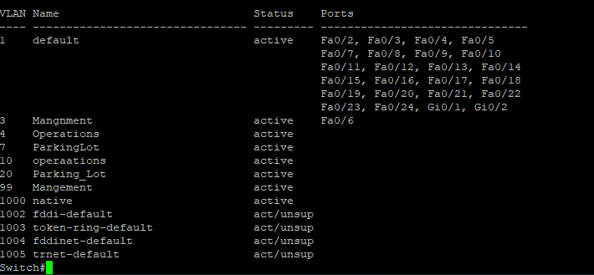

### Create VLANs on both switches.

Open configuration window

* + - 1. Create and name all he required VLANs on each switch from the table above.

Example:

**S1(config)# vlan 3**

**S1(config-vlan)# name Management**

* + - 1. Assign all unused ports on both switches to the ParkingLot VLAN, configure them for static access mode, and administratively deactivate them.

**Note**: The interface range command is helpful to accomplish this task with as few commands as necessary.

### Assign VLANs to the correct switch interfaces.

* + - 1. Assign all used ports to the appropriate VLAN (specified in the VLAN table above) and configure them for static access mode. Be sure to do this on both switches

Example:

**S1(config)# interface f0/6**

**S1(config-if)# switchport mode access**

**S1(config-if)# switchport access vlan 3**

* + - 1. Issue the **show vlan** **brief** command and verify that the VLANs are assigned to the correct interfaces.

Insert Screen shot of both switches:

S1: 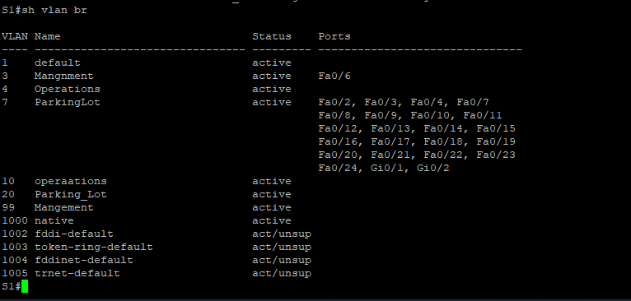

S2:

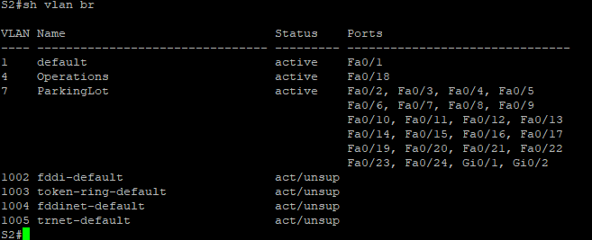

Close configuration window

## Configure an 802.1Q Trunk Between the Switches

### Manually configure trunk interface F0/1.

Open configuration window

* + - 1. Change the switchport mode on interface F0/1 to force trunking. Make sure to do this on both switches.

**S1(config)# interface f0/1**

**S1(config-if)# switchport mode trunk**

* + - 1. As a part of the trunk configuration, set the native VLAN to 8 on both switches. You may see error messages temporarily while the two interfaces are configured for different native VLANs.

**S1(config-if)# switchport trunk native vlan 8**

* + - 1. Issue the **show interfaces trunk** command to verify trunking ports, the Native VLAN

### Manually configure S1’s trunk interface F0/5

* + - 1. Configure the F0/5 on S1 with the same trunk parameters as F0/1. This is the trunk to the router.
      2. Issue the **show interfaces trunk** command to verify trunking.
      3. 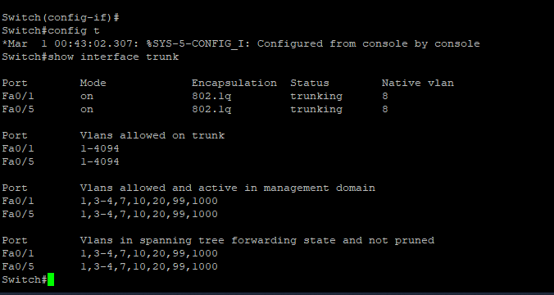

#### Question:

Why does F0/5 not appear in the list of trunks?

Will only become a trunk if the router interface is up

Close configuration window

## Configure Inter-VLAN Routing on the Router

Open configuration window

* + - 1. Activate interface G0/0/1 on the router.
      2. Configure sub-interfaces for each VLAN as specified in the IP addressing table. All sub-interfaces use 802.1Q encapsulation.

**R1(config)# interface g0/0/1.3**

**R1(config-subif)# description Management Network**

**R1(config-subif)# encapsulation dot1q 3**

**R1(config-subif)# ip address 192.168.3.1 255.255.255.0**

* + - 1. Use the **show ip interface brief** command to verify the sub-interfaces are operational.

Insert Screen shot:

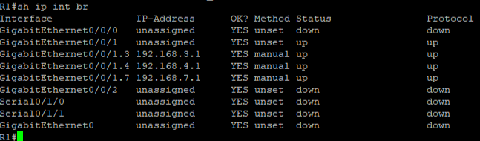

Close configuration window

## Verify Inter-VLAN Routing is Working

### Complete the following tests from PC-A. All should be successful.

**Note**: You may have to disable the PC firewall for pings to be successful.

* + - 1. Ping from PC-A to its default gateway.
      2. Ping from PC-A to PC-B

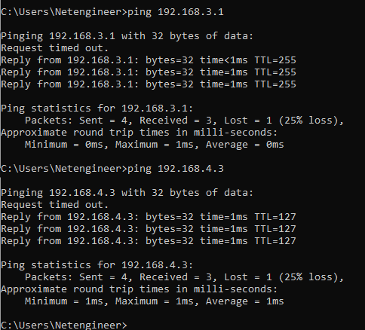

### Complete the following test from PC-B.

From the command prompt on PC-B, issue the **tracert** command to the address of PC-A.

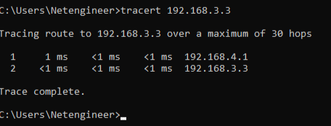

#### Question:

What intermediate IP addresses are shown in the results?

Type your answers here.